Optical Appeal of a Website
Name
Institutional Affiliation

Optical Appeal of a Website
Introduction
An appeal of web design is a concept that has become a matter of consideration over the last century. Every person needs a website that strictly meets the demand based on the design standards. But how much of the success of a particular website can be accredited to visual appeal? To respond to this question, we have to consider that design is just as full as it is prevalent. A well-presented website plays a pivotal role in impacting how the audience perseveres the brand of the website. The kind of impression employed to the website can enhance them to remain on the page and learn about the business or else leave the page and shift to your competitors. Good website design helps and individual to maintain the leads on the website. Regarding the Brown Thomas and Tommy Hilfiger websites, I will demonstrate my looks and feelings/usability that compels me to embrace the Brown Thomas website over the Tommy Hilfiger website since I have experience with the two sites. The paper will focus on considering the headlines of the website on navigation color presentation and text application of images layout of content for ease utilization. In detail, the analysis will be on screenshots of the website in my response to illustrate the point.
Brown Thomas Website Color Navigation
Brown Thomas, in alliance with the Company Limited, is a restraint of four Irish retail establishments, situated in Dublin, Cork, Galway, and Limerick. Claimed by Wittington Investments, Brown Thomas is an upmarket chain, much the same as Holt Renfrew chain of Canada, Selfridge’s stores of Britain, and Netherland’s De Bijenkorf. All of these stalls are constrained by the Weston Family. The navigation color of this platform is more compelling compare to the website of Tommy Hilfiger. Head to the Brown Thomas excellence occasion, Beauty Blossoms, which runs from Thursday, February 18 until March 6 in all stores. From selective dispatches to one-off occasions, it's a wonder someone who is gets used to nirvana – an opportunity to get within track on the most recent in excellence, get visiting global make-together specialists and see the most fantastic new dispatches for spring. The Tom Ford spring excellence assortment is awesome, with Patent Finish lip hues that must be believed to be accepted – touch on for a wonderful shading stain, or layer for the glossiest, shiniest lip gleam we have ever observed (“Brown Thomas Online Stores," n.d).
The website is designed to take all sensible consideration to guarantee that all the details, costs, photographic portrayals and depictions of items showing up on the site are right when the relevant data was entered onto the framework. The website has bent over backward to show as precisely as conceivable the appearances, colors, surfaces, or completes of their items that show up on the site. What you see will rely upon your screen and PC gear. In this regard, the website is incapable of ensuring that the item pictures are a precise portrayal of the genuine product. If you don't mind, allude to the Returns Policy on the off chance you are discontent with your purchase using the website. However, the component that cannot be incorporated may be impacted by the choice of the end device. The image resolution of a device plays a key role in determining the sharpness of the image to be portrayed. Similarly, the number of colors that can be displayed at the same time plays a pivotal role. The client must be able to rely on the colors that are visible in the displayed article for clothing. However, the incongruity existing between the provided colors on the screen and the real color is often considered to be too pronounced. In particular, older mobile gadgets are very few in their capability of revealing the colors. Moreover, the resolution of the image is not at all equivalent to those of the computers.
About Tommy Hilfiger and Its Color Navigation
Tommy Hilfiger among the dynamic fashioner means of life brands within the globe. A lot of this it's globally alleged for complimentary the wealth of typical American cool vogue. It seeks to focus on preppy with a distort style. Tommy Hilfiger conveys quality making, price and incentive to shoppers within the world underneath the brands of Tommy Hilfiger together with Hilfiger, with an opportunity of assortments the embrace Hilfiger assortment, Tommy Hilfiger Personalized, each men's and ladies' and dresses for young adults, denim, frill, and footwear. Similarly, the whole is permitted for a scope of things, together with aromas, eyewear, watches, and residential decorations. Tommy remains to be the principle designer of the organization and provides initiative as well as the bearing to the structure procedure. In the year 2010, it could be a universal apparel and retail business within more than seventeen thousand partners round the domain. With the assistance of solid international consumer response, Tommy has made-up a broad circulation organize in additional than ninety nations and in more than 1,400 selling locations at some stage in Europe, geographical region, and also the region of Asia Pacific. International retail deals of the Tommy Hilfiger who were North American nation $6.7 billion of each in the year 2014. With a heritage returning over two centuries, PVH has surpassed expectations at developing brands and organizations with wealthy American legacies, obtaining one among the most important wear organizations in the world. We have got over thirty thousand partners operating in additional than forty nations with over $8 billion of each 2014 income. We have a tendency to possess the notable Calvin Richard Klein, Tommy Hilfiger, Van Heusen, IZOD, ARROW, Speedo, Warner's associated Olga brands and market an assortment of merchandise underneath these and alternative loosely and globally notable claimed and approved brands (”Tommy Hilfiger Global," 1985).
From the Announcing into the Senior Design Director Underwear Tommy Hilfiger Global, the work will be liable for the vision of an idea, color, and pattern heading for Tommy Hilfiger Underwear and Loungewear, working intimately with the Senior Design Director to lead the brand vision. Ensure an appropriate handover of the item plan to the product improvement office and advancement sources. The fundamental obligation is to present all pertinent data required for the advancement procedure. For example, a unique plan, shading sign, execution data, and configuration parts sizes. Research regular/pattern ideas, materials, and equipment and color stories. Group into temperament sheets to introduce back to Senior Design Director and group. In regard to the above Brown Thomas and Tommy Hilfiger websites as far as color navigation is put into consideration, both websites display the color to their best to appeal to their potential customers. However, the Brown Thomas website has the best presentation as I have the best experience ever with the website.
2. Text use of images layout of content ease use
Through the Brown Thomas website, a live messaging feature is provided. The live chat enhances the customer services that permit the users to connect with team members through the live chat feature. This software is issued by the third party bearing the name Salesfloor. The company gathers the information on the name of the customer, email of the customer, and details concerning the query of the customer as they insert in the text field “what can I help you with? Upon submission of this information, the customer is issuing consent for the responsible team leader in applying the details to communicate with the client on following the query. 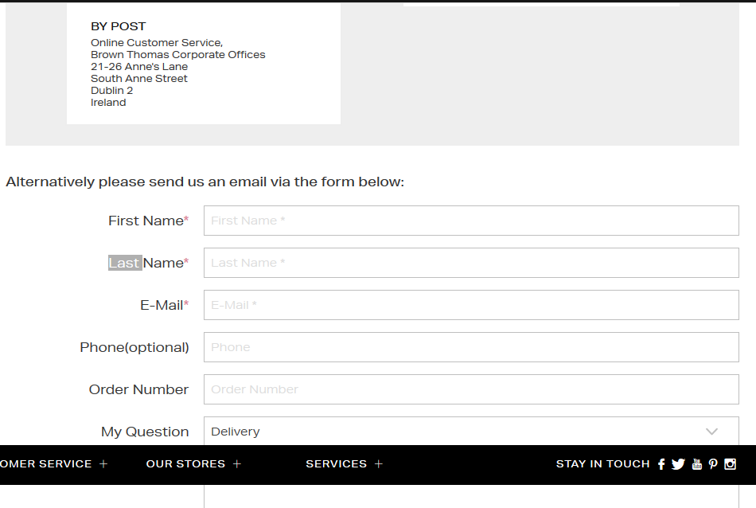The image is a presentation of the live chat screenshot of the Brown Thomas website.
To the case of Tommy Hilfiger’s website, the website is switching to short SMS codes for communication between the clients and the responsible teams of the website. The illustration below is the screenshot of the SMS that is conveyed to the subscribers. 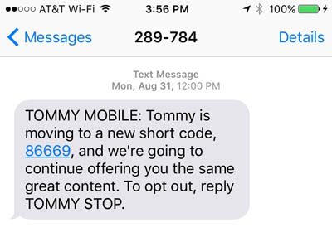Text Use of Images Layout of Content Ease of Use. The organization names it list as Tommy Mobile. It is conveyed out the subsequent message from SMS code number 289784 towards the numbers of the subscribers. Rather than sharing dull instant messages about changing to another SMS short code, Tommy Hilfiger's line about "we're going to keep offering you a similar extraordinary substance," is a decent one. Wet Seal, a ladies' dress chain, splits jokes when telling clients they're exchanging numbers. This is an incredible method to help facilitate the potential disturbance of such a move, particularly when you're similar to Wet Seal and switch SMS short codes on various occasions out of the blue. The advantage of live chat messaging feature over SMS codes is that live chat tends to boost customer loyalty. A strong relationship is built, and this reduces the likelihood of shifting to the competitor, offering the same services, or selling the same products. More so, the consumers become less sensitive concerning the price tagged against the product. All these benefits are with the Brown Thomas website.
In regard to Subject to Brown Thomas platform, the customer’s correspondences inclinations, the platform will get in touch with you now and again with advancements and publicizing for items, administrations, or occasions. You can quit accepting interchanges or change your inclinations by means of your Brown Thomas Online Account or your Arnott’s online record. Quitting implies you may pass up advancements or limits that will bear some significance with you. The platform staff tracks the open rates and responsiveness rates on our email crusades. At the point when you visit the sites, it composes an assortment of treats identifying with the elements of the site and furthermore to follow how you connect with the site so the platform can recognize chances to improve its value to their customers. For more data on Cookies, the platform uses, see the 'Protection and Cookies Policy' segment. This hence makes Brown Thomas surpass Tommy Hilfiger's website by far as the conveyance of text.
Conclusion
For the researchers, there are three ways to hurriedly compare the website with other competitors. This is for individuals or organizations that may be focusing on developing the website. These are the website technology that contains website architecture, page speed. The second factor to be considered is website content. The content of the website contains organic keyword research and on-page optimization. The third factor is the backlinks. Last Takeaways on Competitor Analysis, the substance and connections will keep on being the foundation of Google's calculation for quite a while. Understanding what you are facing and killing any contender focal points is a significant advance when building up a viable showcasing effort. The line that up with the improvement of novel and valuable substance and nothing can prevent you from administering the SERPs.

References
Tommy Hilfiger Global. (1985). Retrieved from https://global.tommy.com/en_int/about-us
Brown Thomas Online Stores. (n.d). Retrieved from https://www.brownthomas.com/new-in/

